**International Space Station Toilet Tour**

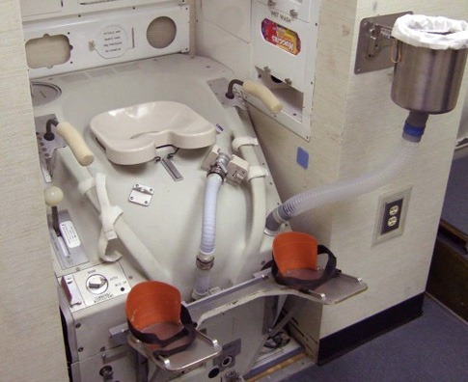

1. **Match the vocabulary with the correct definition and write a-j next to the numbers 1-10.**

|  |  |  |  |
| --- | --- | --- | --- |
| 1 | a restroom | 5 | 1. having no weight |
| 2 | to do ‘one’s business’ | 9 | 1. approximately |
| 3 | courtesy | 6 | 1. the liquid waste that comes out of your body when you go to the toilet |
| 4 | suction | 2 | 1. to urinate or defecate |
| 5 | weightlessness | 10 | 1. to grasp or take hold of suddenly |
| 6 | number one/pee/urine | 3 | 1. thoughtfulness |
| 7 | number two/poo/faeces | 8 | 1. safe drinking water |
| 8 | potable water | 7 | 1. the solid waste that comes out of your body when you go to the toilet |
| 9 | roughly | 1 | 1. a toilet in a public place (American English) |
| 10 | to grab | 4 | 1. removal of air |

1. **Watch a video about the *International Space Station* *Toilet* and highlight *true* or *false* for these sentences.**

|  |  |  |
| --- | --- | --- |
| 1. The International Space Station is also called ISS | true | false |
| 1. Samantha Cristoforetti suggests that, by turning on the fan, the bad smells will be eliminated. | true | false |
| 1. The fan creates a suction which allows the astronauts to do a number two in weightlessness. | true | false |
| 1. Samantha tells us that most of the astronauts prefer not to sit on the actual toilet seat. | true | false |
| 1. On day sixty-one, according to Samantha Cristoforetti, the solid waste container will have to be changed again. | true | false |
| 1. The solid waste container is changed roughly every ten days if there are four astronauts on board. | true | false |
| 1. Urine is recycled on the space station. | true | false |
| 1. The UPA is the last step in turning urine into drinking water. | true | false |

1. **Write a number (1-6) to put these sentences in order.**

|  |  |
| --- | --- |
| 3 | Turn the rotor to ninety degrees. |
| 1 | Go into the restroom. |
| 2 | Take the piece of equipment off the wall. |
| 6 | Put a new bag inside for the next person. |
| 5 | When you have finished, push the bag into the solid waste container. |
| 4 | Turn on the fan. |

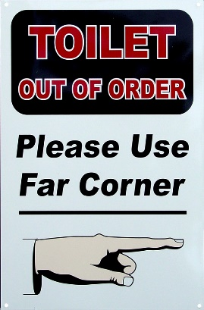

1. **Discussion**  
   Would you like to go into space? What do you think are the best and worst things about being an astronaut? Write down at least five sentences (*I think…/I would like to/I wouldn’t…*)!